**User Guide**

* Quick Start
* Features
* Help
* Input History
* Add
* Edit
* Delete
* Clear
* Done
* Undo
* Redo
* List
* Find
* Store
* Exit
* FAQ
* Command Summary

**Quick Start**

1. Ensure you have Java version 1.8.0_60 or later installed in your computer.

Having any Java 8 version is not enough.   
  
This app will not work with earlier versions of Java 8.

1. Download the latest DearJim.jar from the releases tab.
2. Copy the file to the folder you want to use as the home folder for DearJim.
3. Double-click the file to start the app. The GUI should appear in a few seconds.

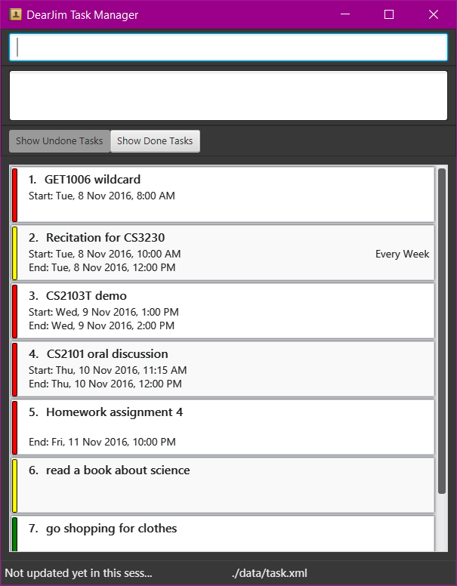

Figure 1: GUI of DearJim

1. Type the command in the command box and press Enter to execute it.   
     
   e.g. typing **help** and pressing Enter will open the help window.
2. Some example commands you can try:

* **list** : lists all tasks. This is the default view.
* **add** Learn how to use DearJim : adds a task to DearJim.
* **delete** 1 : deletes the first task shown in the current list.
* **exit** : exits the app.

1. Refer to the Features section below for details of each command.

**Features**

**Command Format**

* Format: <command word> <parameters>
* Words in UPPER_CASE are the parameters.
* Fields in [] are optional.
* The order of parameters is fixed.

**Viewing help: help**

Opens a help window that contains a cheat sheet of all the commands of DearJim.  
  
You can leave the help window open while using DearJim if you need to refer to the cheat sheet.

Format: help

While the help window is selected, you may close it by simply pressing any key on your keyboard!

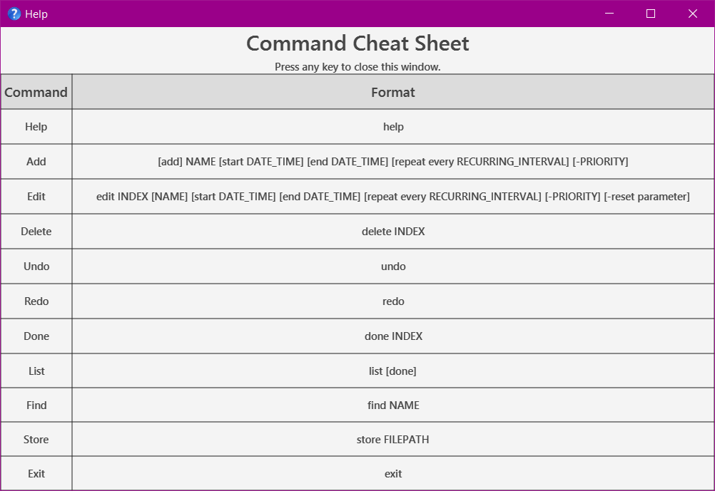

Figure 2: Help Command

**Input History**

Use the Up and Down arrow keys to navigate your input history.  
  
This gives you quick access to your previous and next inputs.

**Adding a task: add**

Adds a task into DearJim.  
  
Format: [add] NAME [start DATE_TIME] [end DATE_TIME] [repeat every RECURRING_INTERVAL] [-PRIORITY]

You may also substitute start with from/at, end with to/by.

By default, if no valid command is specified, the input will be treated as an add command. This means typing in add is optional.   
  
If you would like to add a task with a name that begins with other command words, just include the add to override the other command words.

Example:

| **Input** | **Interpreted Command** | **Result** |
| --- | --- | --- |
| help my mum to buy cooking ingredients | help | Execute help command |
| add help my mum to buy cooking ingredients | add | add a task with name help my mum to buy cooking ingredients |

***Adding a task***

Format: NAME

The simplest form of a task. Type away!

Example:

* help my mum to buy cooking ingredients

***Specifying task priority***

You can assign a PRIORITY of low, medium or high to your task.   
  
Tasks have medium PRIORITY by default.  
  
Keyword: -PRIORITY

To specify the priority for a task, input a - followed by the PRIORITY.  
  
PRIORITY also accepts variations of low, medium and high.

| **PRIORITY** | **Variations** |
| --- | --- |
| low | l, low |
| medium | m, med, medium |
| high | h, high |

Examples:

* Watch drama -l
* Buy coffee powder -med
* Buy washing powder -high

***Adding a task with deadline***

Nobody likes deadlines. What's worse is missing them.   
  
Add deadlines to your task so you will know when you need to complete them!  
  
Format: NAME end DATE_TIME [repeat every RECURRING_INTERVAL] [-PRIORITY]

end denotes a deadline.   
  
end can also be substituted with by or to.

DATE_TIME is flexible!

* If no DATE is specified, DATE will be assumed to be today.
* If no TIME is specified, TIME will be assumed to be 11:59pm.

***Valid Dates & Times***

| **Date** | **Format** | **Interpreted Date** |
| --- | --- | --- |
| MM/DD/YYYY | 12/12/2016 | 12 December 2016 |
| MM/DD/YY | 12/12/16 | 12 December 2016 |
| MM/DD | 12/12 | 12 December, Current Year |
| Calendar | 12 December 2016, 12th December 2016 12 December 16 | 12 December 2016 |
| Calendar (Date and Month) | 12 December | 12 December, Current Year |
| Calendar (Month) | may, May dec, Dec, December | 1 May, Current Year 1 December, Current Year |
| Day | monday, Mon | Nearest upcoming Monday |
| Relative Date | today, tonight tmr, tommorow next Tues 5 days later | Today Tomorrow Next Tuesday 5 days later |

| **Time** | **Format** | **Interpreted Time** |
| --- | --- | --- |
| 24Hr | 20.50, 20:50 | 8.50pm |
| AM/PM | 8.50pm, 8:50pm, 0850pm | 8.50pm |
| Preset | midnight noon | 12am 12pm |

DearJim does not support the following 24hr format: 2050, as this input can be misinterpreted as the value of year.

Examples:

* Do project proposal by 5pm tmr
* eat lunch by 1pm today -high
* Buy coffee for boss by 7:00
* finish CS2101 assignment by 13th Sep

NAME with numbers from 0000 to 2359 may be wrongly interpreted as time. If you need to add a NAME with these numbers, you can enclose the NAME with double inverted commas to denote the NAME explicitly.

Example:

| **Input** | **Interpreted Command** | **Interpreted Task Name** | **Interpreted Deadline** | **Result** |
| --- | --- | --- | --- | --- |
| Lower word count by 1500 | add | Lower word count | by 1500 | add a task with name Lower word count and deadline 1500 |
| "Lower word count by 1500" | add | Lower word count by 1500 | NONE | add a task with name Lower word count by 1500 |

***Adding a task with time interval***

Having a company meeting? Planning to have lunch with a friend next week?   
  
Add a task with a time interval so you will know what time your task starts and ends!  
  
If you are unsure about the end time for the task, you can leave it blank.  
  
Format:  
NAME start DATE_TIME [end DATE_TIME] [repeat every RECURRING_INTERVAL] [-PRIORITY]

Note: You may use from or at to indicate the start time, and to or by to indicate the end time.

Example:

* Company meeting tonight at 7pm to 9pm
* Family dinner at noon
* Meet Akshay from 1pm -h

***Specifying repeated tasks***

Have one of those pesky tasks you need to do every now and then?  
  
DearJim also allows you to specify tasks that need to be repeated at a specific RECURRING_INTERVAL. Never forget them again!  
  
Keyword: repeat every RECURRING_INTERVAL

Note: You may only specify a RECCURING_INTERVAL for tasks that are timed.

RECURRING_INTERVAL can be specified in a few formats, with some examples listed below.

| **Recurring Interval** | **Format** |
| --- | --- |
| Hour | hour, 3 hours |
| Day | day, 3 days, monday, mon |
| Week | week, 5 weeks |
| Month | month, 2 months |
| Year | year, 6 years |

Examples:

* Run at track at 7am repeat every 3 days
* Visit mum repeat every sun

**Editing a task: edit**

Just in case you need to change any details, or add in missing ones into your task, simply edit them in DearJim.   
  
Format: edit INDEX [NAME] [start DATE_TIME] [end DATE_TIME] [repeat every RECURRING_INTERVAL] [-PRIORITY]

INDEX refers to the task number in the current displayed list.  
  
Note: edit has a very similar format to add.

Examples:

* Company meeting tonight at 7pm to 9pm
* edit 2 Company meeting tomorrow morning at 7am to 9am -high
* Buy coffee for boss by 8am repeat every day
* edit 3 Buy coffee for boss by 7am repeat every 2 days

***Editing out details in a task***

You can also remove parameters that are no longer relevant.   
  
Format: edit INDEX [-reset parameter] [repeat] [start] [end]

| **-reset parameter** | **Result** |
| --- | --- |
| -reset repeat | Removes recurring interval from task |
| -reset start | Removes start time from task |
| -reset end | Removes end time from task |

Examples:

* Buy coffee for boss, by 8am repeat every day
* edit 1 -reset repeat start
* edit 2 -reset end

Note: -reset will override any edit of the same field that comes before it in your input.

**Deleting a task: delete**

Deletes an existing task in DearJim. This will remove it from the storage.   
  
Format: delete INDEX

You can delete multiple tasks using a single command by entering the indexes of the tasks you want to delete, separating each index with a space.

Example:

* delete 2
* delete 3 5 9

**Clearing all tasks: clear**

Deletes all tasks in DearJim.  
  
Format: clear

**Archiving a task: done**

Marks a task as done and archives it in DearJim.  
  
Format: done INDEX

You can done multiple tasks using a single command by entering the indexes of the tasks you have completed, separating each index with a space.

Example:

* done 3
* done 1 5

**Undoing a command: undo**

Reverses the effects of the previous undoable command.   
  
Helps you to undo any accidental mistakes that you have made!   
  
Format: undo

Commands that you can undo (Undoable commands):

* add
* edit
* delete
* clear
* done

**Redoing a command: redo**

Reverses a previous undo command.   
  
Not satisfied with your last undo? redo will reverse the undo for you!

Format: redo

Note: redo can only reverse your last undo if no undoable commands have been entered after that undo.

**Listing tasks: list**

***Listing all undone tasks***

Switches the task list view to the undone list view, to show all undone tasks in DearJim.  
  
Format: list

***Listing all undone tasks of a specific day***

Switches the task list view to the undone list view, to show all tasks on the day specified.  
  
Format: list DAY

Example:

* list today
* list tmr
* list monday

***Listing all done tasks***

Switches the task list view to the done list view, to show all done tasks in DearJim.  
  
Format: list done

add and edit commands do not work in done list view. As such, you are not able to directly add tasks into the done list, or edit the details of done tasks.

**Finding a task: find**

Forgot about the details of a task that you have added earlier? You can find an existing task by its name.  
  
Format: find NAME

find is case-insensitive - find AKSHAY will match find akshay

If no NAME is provided, all uncompleted tasks will be displayed

Examples:

* find Akshay
* find company meeting
* find

**Changing storage location: store**

Need to look at your task on the move? Simply store the data at another location and bring it along with you.  
  
In addition to changing the storage file location, store handles your existing data in two different ways, depending if the filepath you specify is an existing storage file.  
  
If the storage file specified is not present, DearJim will create this new file and store your current data in it.  
  
If the storage file specified is present, data will be loaded from this storage file into DearJim.

Format: store FILEPATH

DearJim data is stored in XML file format. There is no need to specify the file extension .xml, it will be appended to your target file name automatically. store supports both relative and absolute file paths.

Examples:

* store data/onthemove
* store /Users/jim/Dropbox/filename

**Exiting the application: exit**

Closes the application.  
  
Format: exit

**Getting hints for command format**

If you have forgotten about the command formats, simply type any word and DearJim will provide you hints on the command format that you might want to use!

Examples:

* Typing add in the command input generates the format for add in the result display

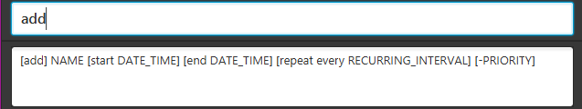

Figure 3: Hints for add command

* Typing delete in the command input generates the format for delete in the result display

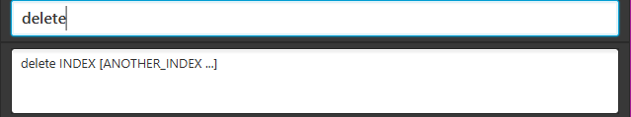

Figure 4: Hints for delete command

**Instant add and edit task preview**

DearJim features an instant add and edit command task preview, allowing you to preview the task details as your type your input!  
  
Now you can be sure of how your input will be interpreted!

Examples:

* Typing add do my homework from 3pm to 4pm repeat every day -high generates an instant add preview

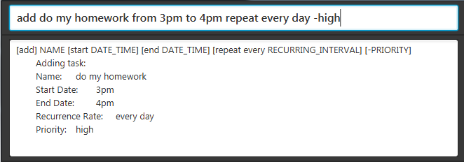

Figure 5: Instant preview for add command

* Typing edit 1 by 10pm -low -reset repeat generates an instant edit preview

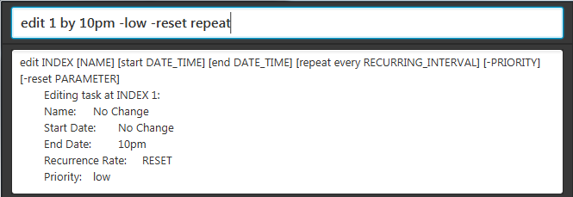

Figure 6: Instant preview for edit command

**Saving the data**

Data in DearJim is automatically saved on the hard disk after any command that changes the data is executed.  
  
There is no need to save manually.  
  
You will never have to worry about forgetting to save your data while using DearJim! Hurray!

**FAQ**

**Q**: How do I transfer my data to another computer?  
  
**A**: Install the app on the other computer. Upon starting DearJim, an empty data file is created. Overwrite the contents of the data file with the data file in your previous *DearJim* folder.

**Q**: How do I install the program?  
  
**A**: Double-click the DearJim.jar file.

**Command Summary**

| **Command** | **Format** |
| --- | --- |
| Help | help |
| Add | [add] NAME [start DATE_TIME] [end DATE_TIME] [repeat every RECURRING_INTERVAL] [-PRIORITY] |
| Edit | edit INDEX [NAME] [start DATE_TIME] [end DATE_TIME] [repeat every RECURRING_INTERVAL] [-PRIORITY] [-reset parameter] |
| Delete | delete INDEX |
| Clear | clear |
| Done | done INDEX |
| Undo | undo |
| Redo | redo |
| List | list [done] |
| Find | find NAME |
| Store | store FILEPATH |
| Exit | exit |